***ITMD 510 Final Project Report Fall 2016***

**Title:** Shopping Center Application

**Introduction:** In the era of Computers, online shopping has become a huge boost for people and the popularity has increased day by day. The importance of online shopping is people don’t need to go to stores or wait for festival seasons to get discount and shop online. There are some or the other offers going on continuously so that people keep on coming to the website again and again.

**Business Logic:** Shopping Center Application is developed as a Java Final project where customer can visit, login and search different items on the application. He can use the forgot password option is he is not able to login to the application. He can proceed with adding items in his cart and check out after making payment. Here customer will be one type of user who can shop by department or its classification, add/remove product from his cart, make payment. Customer can shop by all items where he can see list of all items available. A cache is used to maintained the details of the current user who is logged in so that it’s easier to retrieve his shopping details. Admin is another user who is responsible for adding items in the inventory. Admin will make new departments and categories, add/edit item details, update items in the stock. Shopping center application will have different departments and each department will have different classification. For example: Electronics and Devices is one department which have different categories like TV, Home Theatre, Computer, Laptop, Mobile Phones, Storage Devices, Accessories and each category will have items based on the classification.

**Application Working:** Functionality on how the application will work will be shown below in the snapshots which will have labelled details about when the page opens and what is the action.

Types of User: Admin, Customer

Admin: Add, Edit, Delete, View Department

Add, Edit, Delete, View Classification

Add, Edit, Delete, View Items

Go to home page, logout

Customer: Shop by department

Shop by Classification

Shop by Item

Add Items to cart, view items in cart and proceed to pay

Remove Items from cart, pay for current items in cart, cancel payment

Go to home page, view cart, logout from application

**Next page contains all screenshots of the working application.

Credentials:

For admin below credentials can be used:

username-**khede** password – **khede** OR username-**admin** password – **admin**

For customer below credentials can be used:

username-**skhede** password – **skhede** OR username-**user** password – **user**

**Screenshots:** Below are the labeled screenshots of the working application

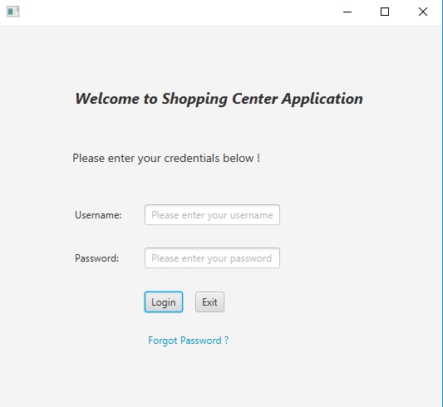

Login Page where Admin and Customer both can login

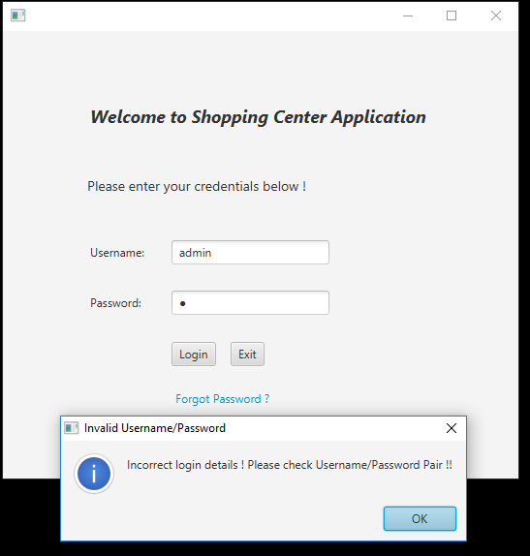

Incorrect Username/Password pair for admin as the details are fetched from the database and the pair doesn’t exist.

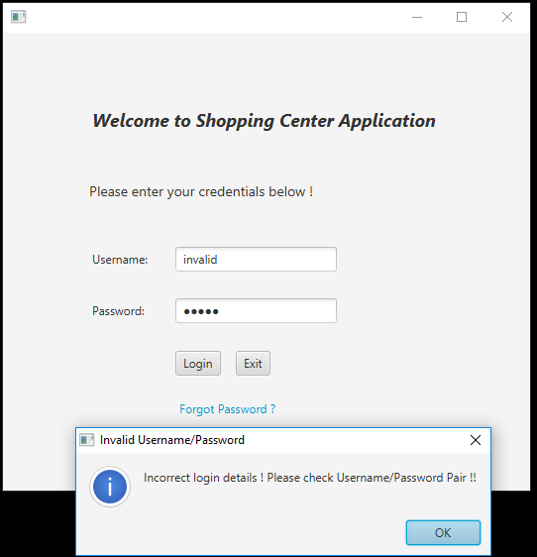

Incorrect Username/Password pair for admin as the details are fetched from the database and the pair doesn’t exist.

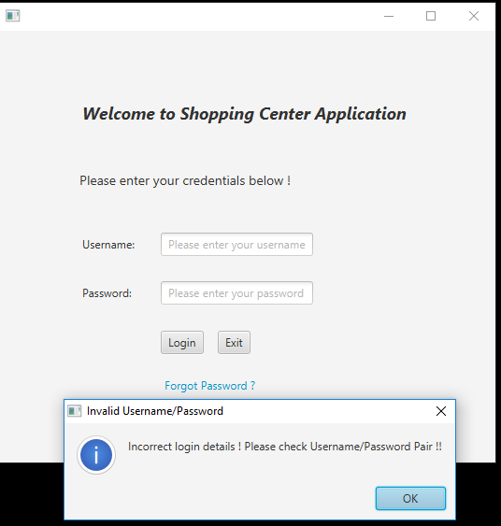

Blank username and password check which doesn’t allows to enter the application.

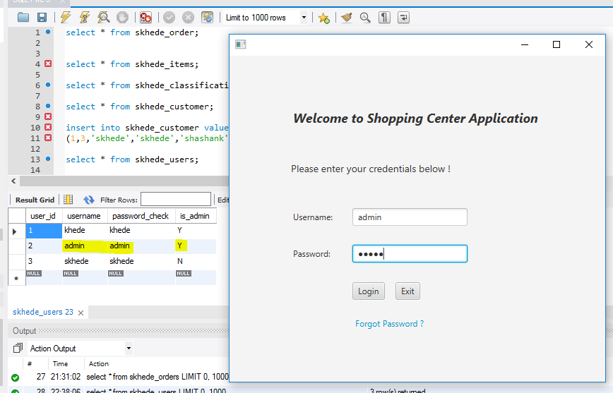

Valid pair of username and password which exist in the database and will check is the user is admin or not. Here in the above screenshot, admin home page will be displayed to admin user.

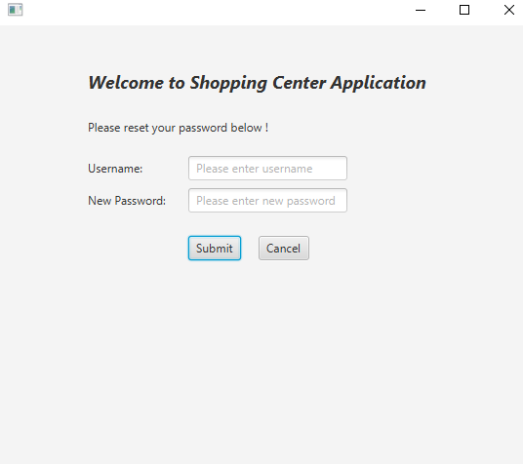

Forgot password page to reset the password.

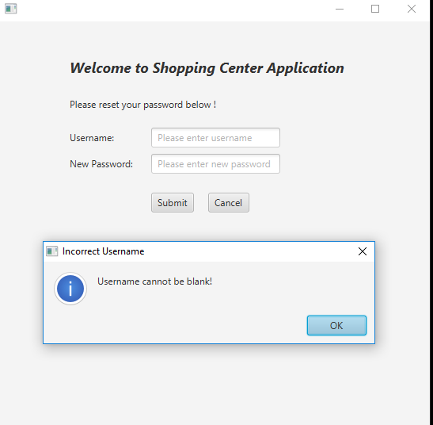

Blank username validation for password reset

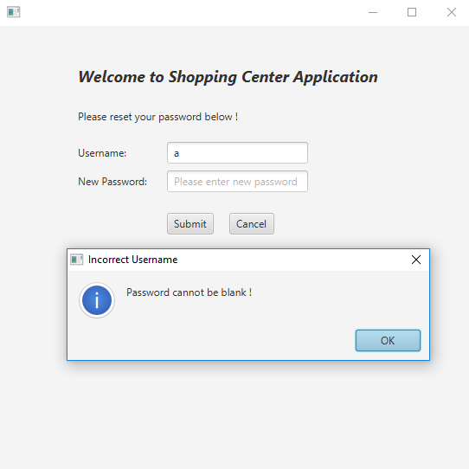

Blank Password validation for user.

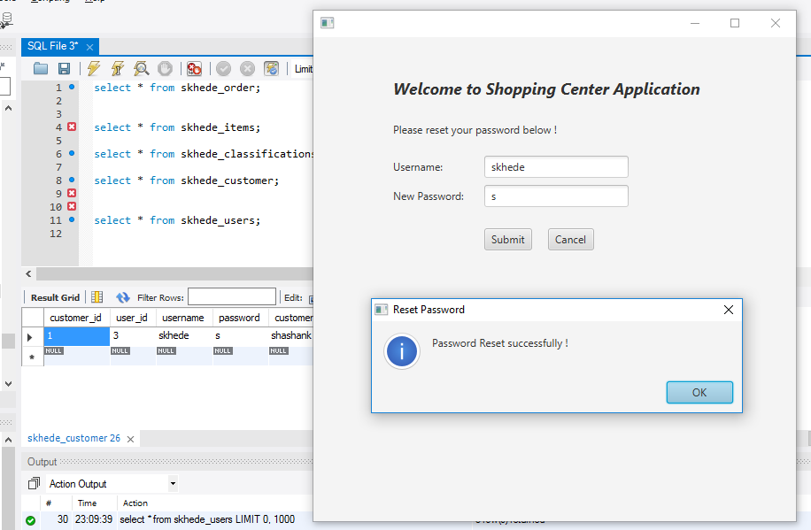

Password reset successfully and updated in the database

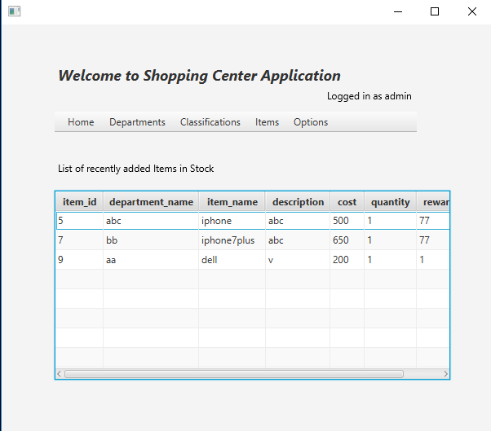

Admin Home page where he can choose different options from the menu and see a list of items which are added to the stock.

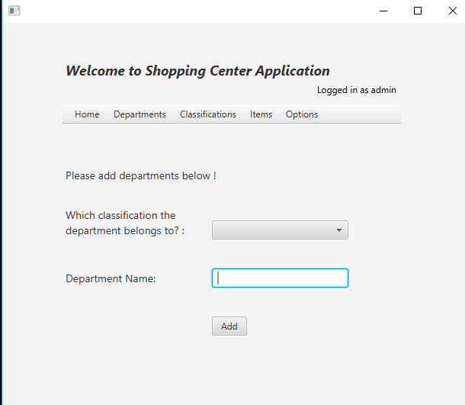

Admin add department page

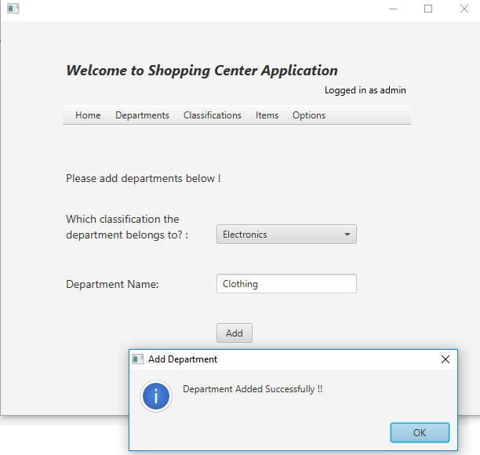

After selecting Classification from dropdown and department name, admin can add department successfully.

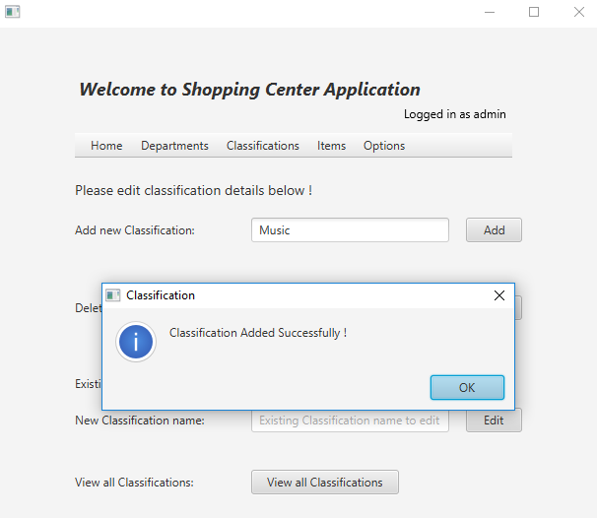

Admin can add new classification.

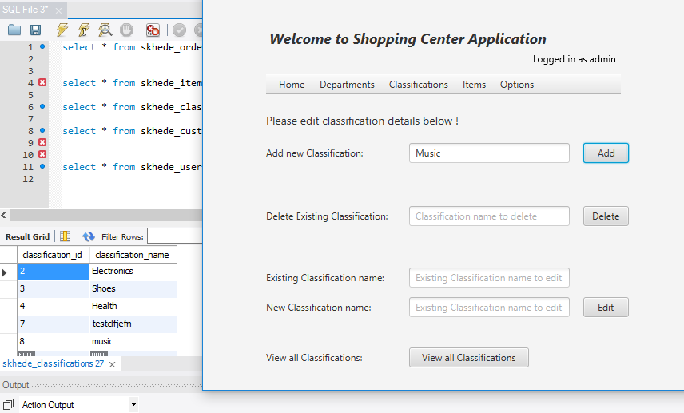

New classification added in table successfully.

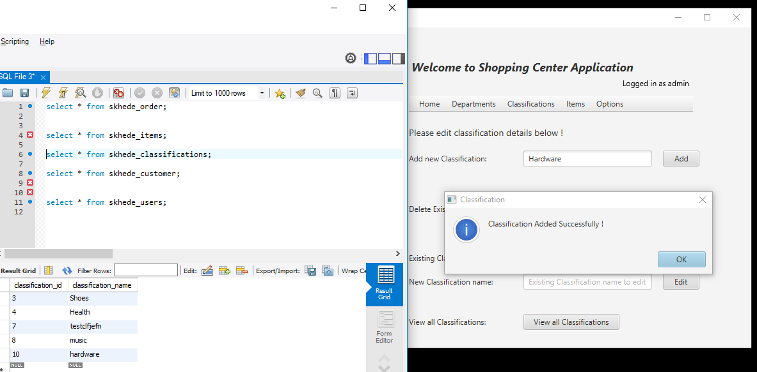

Adding and deleting a department (delete screenshot below)

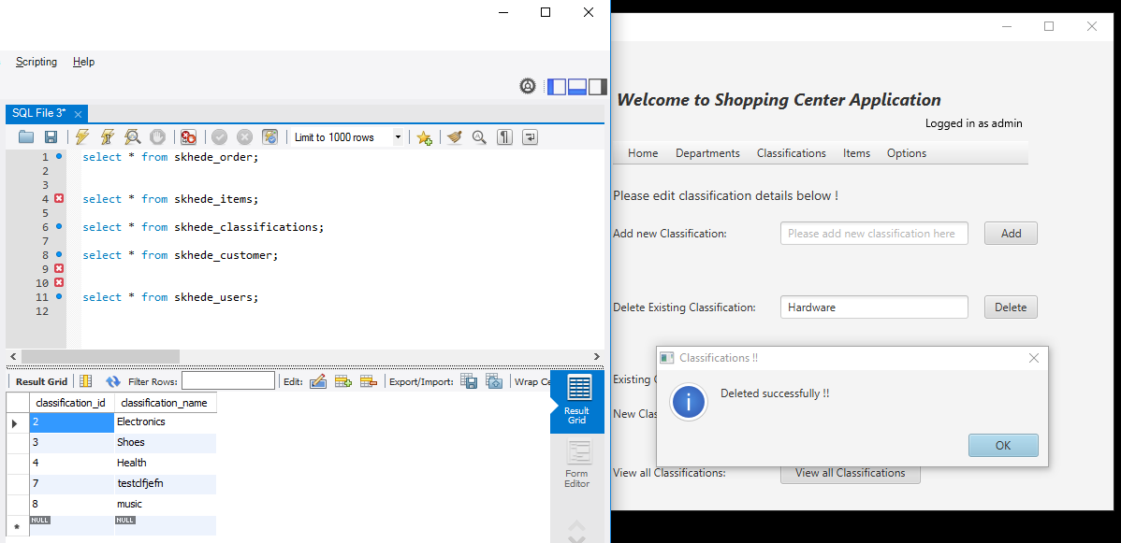

‘Hardware’ classification deleted successfully !

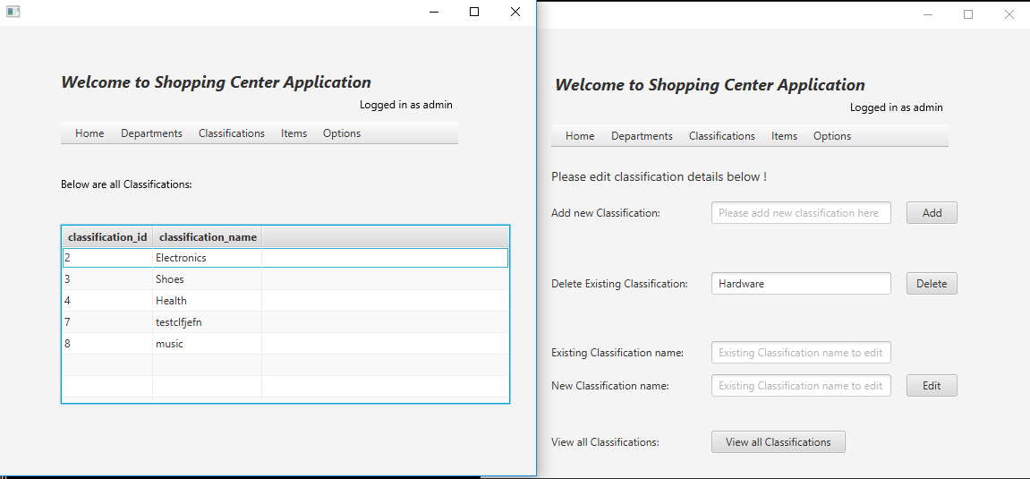

On clicking view all classification, all the classification in the database are displayed successfully.

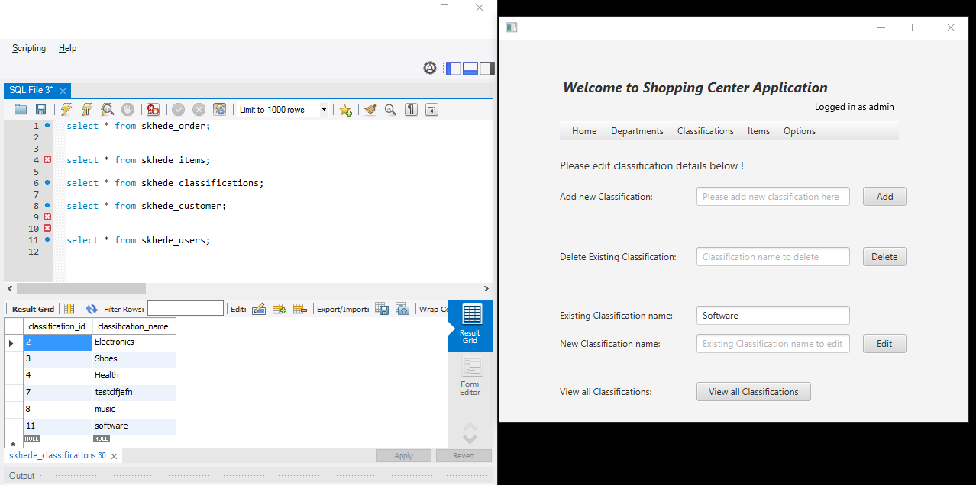

Editing an existing classification named ‘Software’ (edited screenshot below)

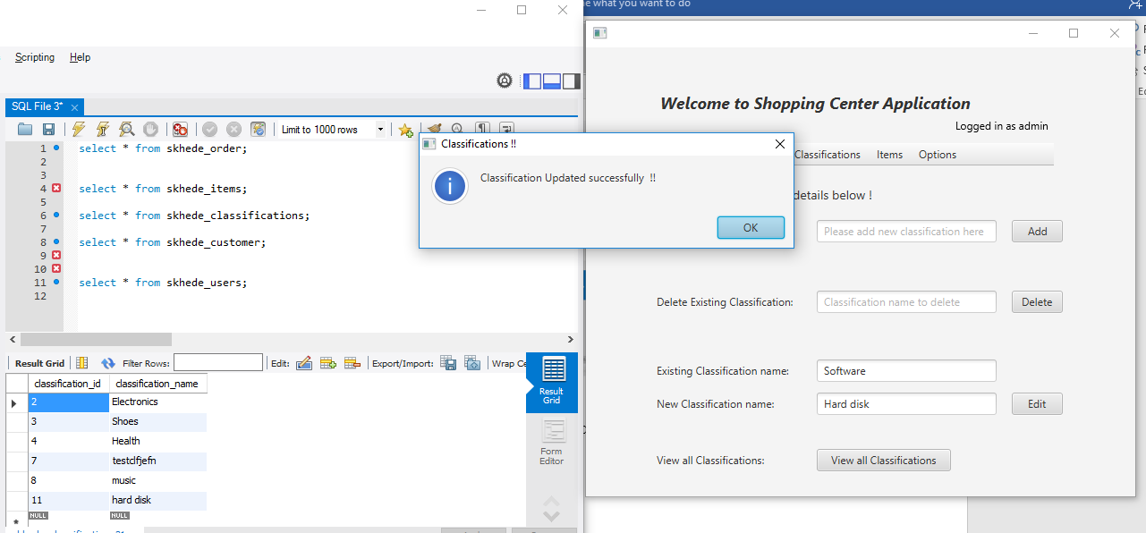

Classification updated successfully.

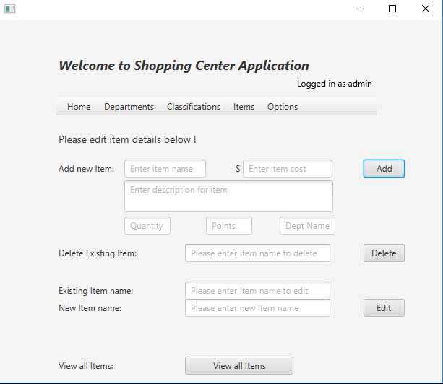

Items menu where admin can add edit delete and view all items

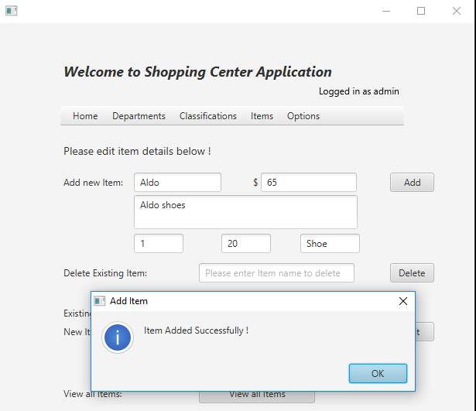

Admin can add new items in the inventory.

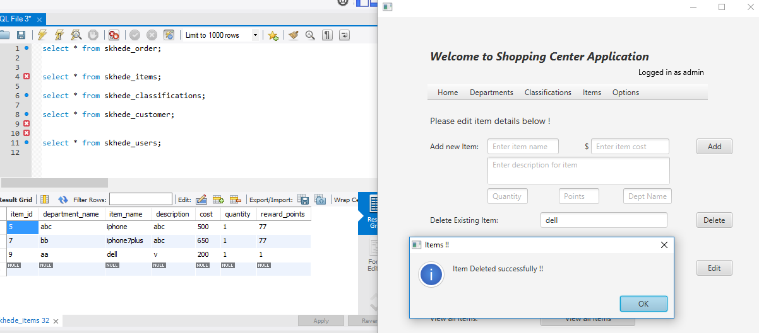

AN existing item in the database with item name Dell is deleted successfully. (Screenshot below after delete)

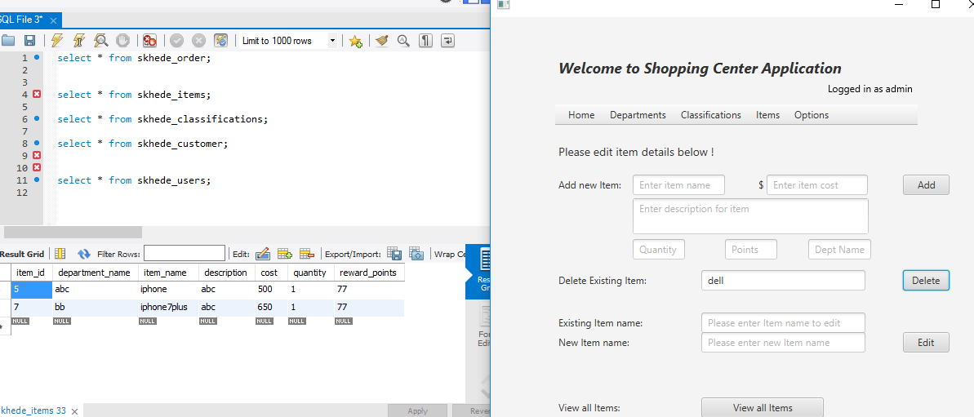

Item deleted from database

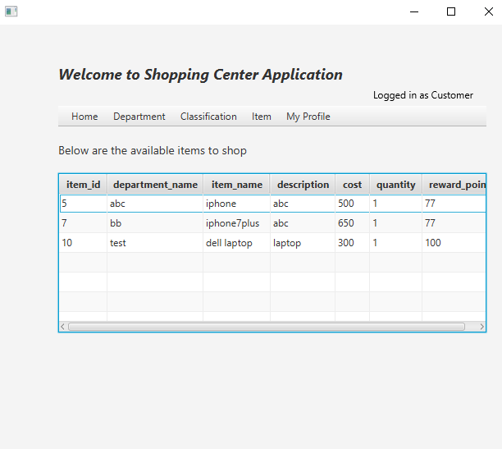

Customer home page where he can shop by classification, department items.

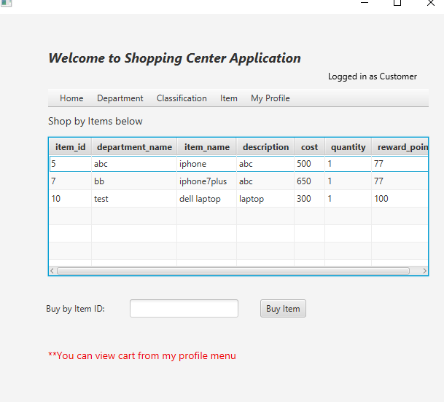

Shop items by putting item it. Items will be added to the cart

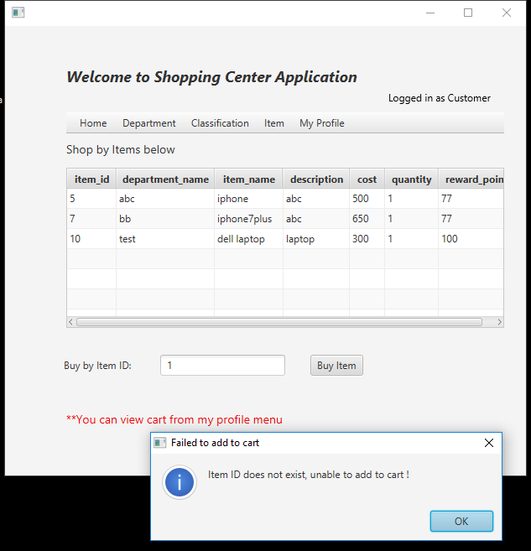

Not able to add invalid items to the cart.

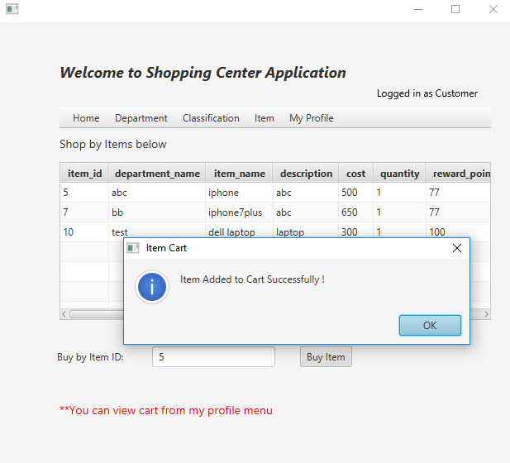

Item added to cart successfully

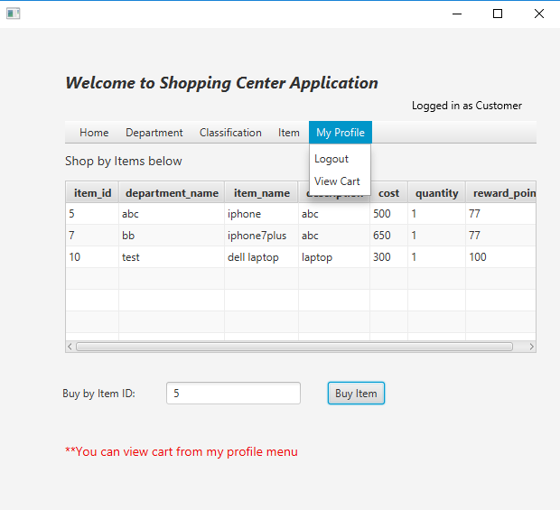

Customer can view items in his cart from View cart option.

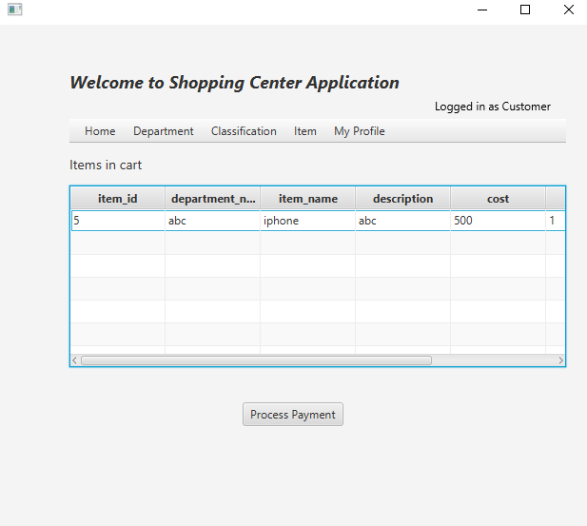

After adding item to the cart, customer can proceed to pay.

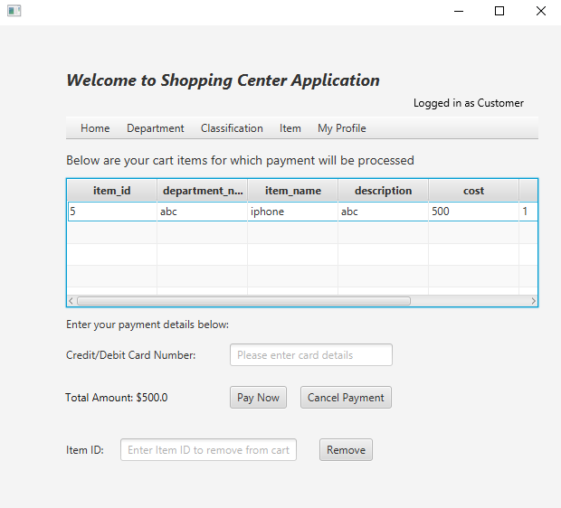

Total amount is updated as per the items in the cart and the items are displayed in the cart for payment when Process Payment is clicked.

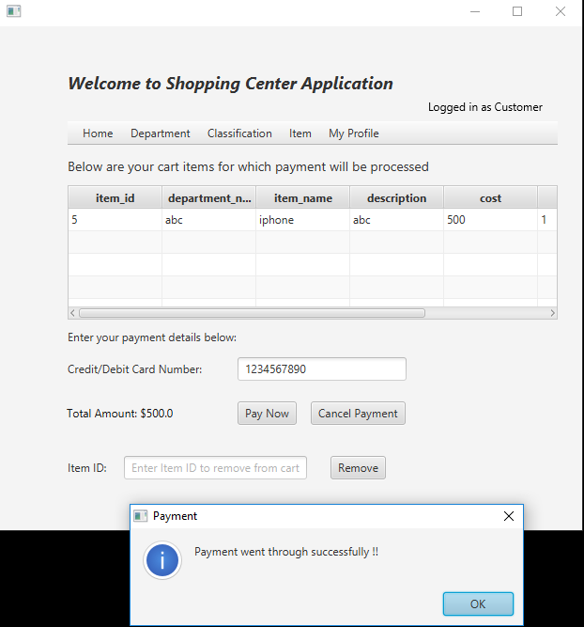

After entering debit/credit card details, payment was successfully message is displayed.

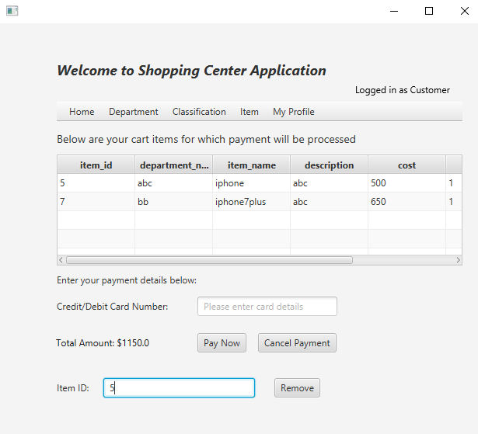

Customer can put Item id and remove it from the cart if he doesn’t need it. The page needs to be refreshed once item is deleted. (Updated cart screenshot below)

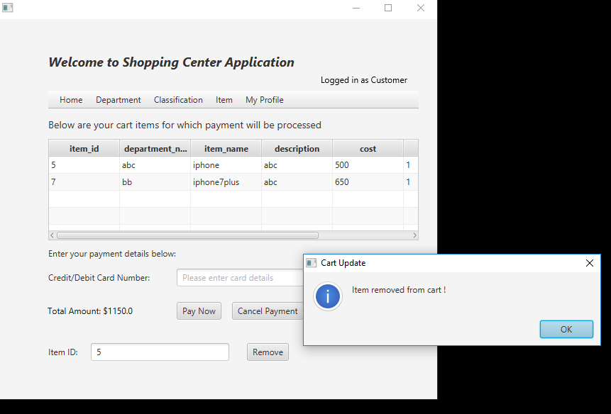

Item remove from the cart.

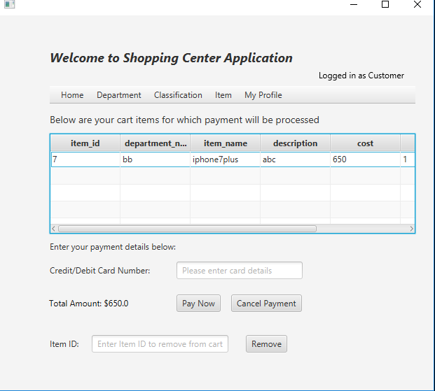

Cart has only one item left to buy after deleting from stock.

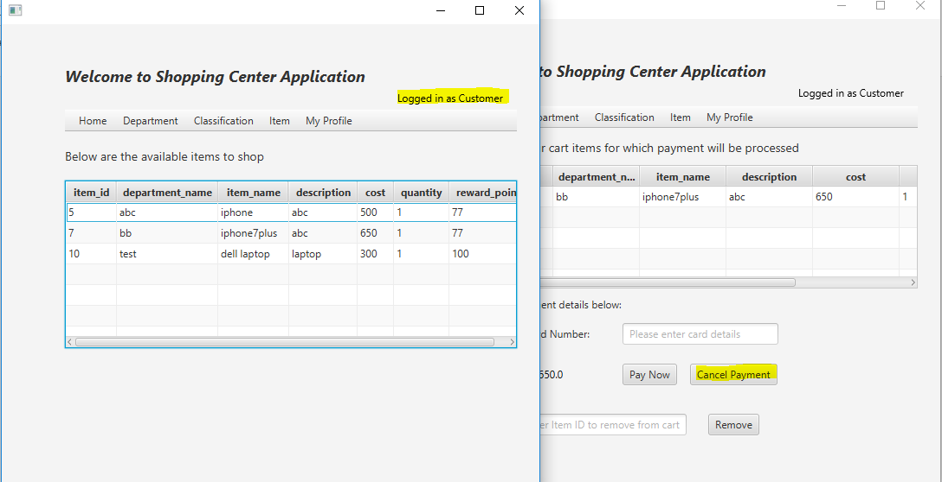

On clicking on cancel payment, it will take customer to the home page.

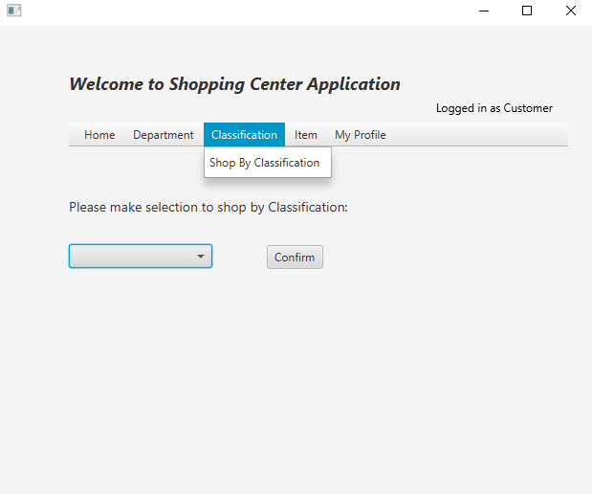

Customer can shop by classification by selecting from the dropdown.

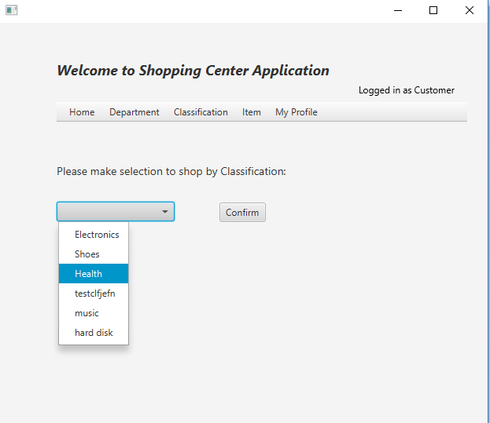

Customer can make selection and click confirm button to see items and proceed to checkout.

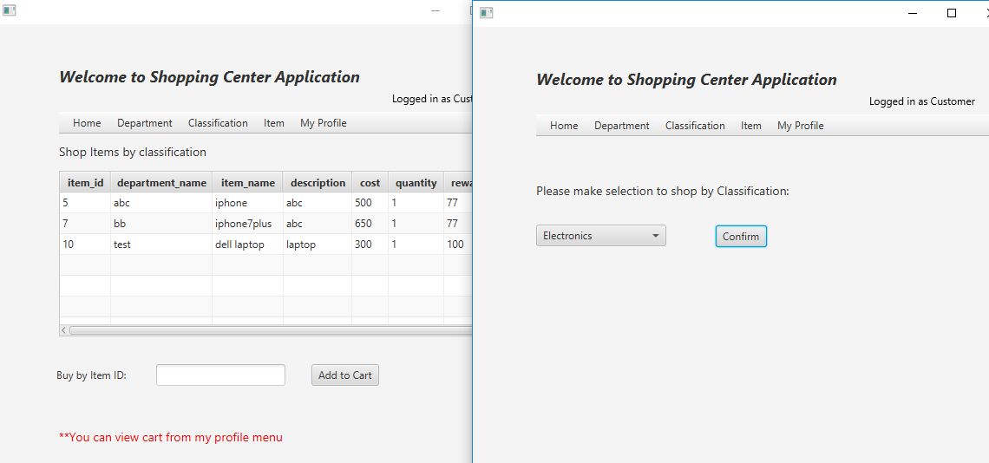

Customer can add the items to cart and proceed to payment in the same way he did before.

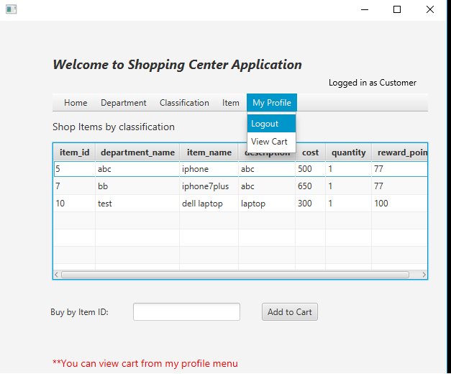

Logout button takes customer to the login page again.

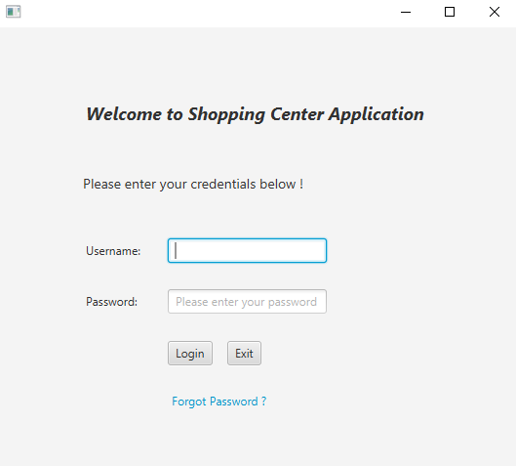

After logging out the login page is displayed and customer can login again or can exit from the application.